The activities within AssociationSphere are organized in modules. This guide provides a description of those activities along with links to articles and videos to learn more. The training videos can be found in the Video Support Library located under the user icon menu in the top right corner of the page. Use password “ASOnDemand” to access the library and the individual video links.
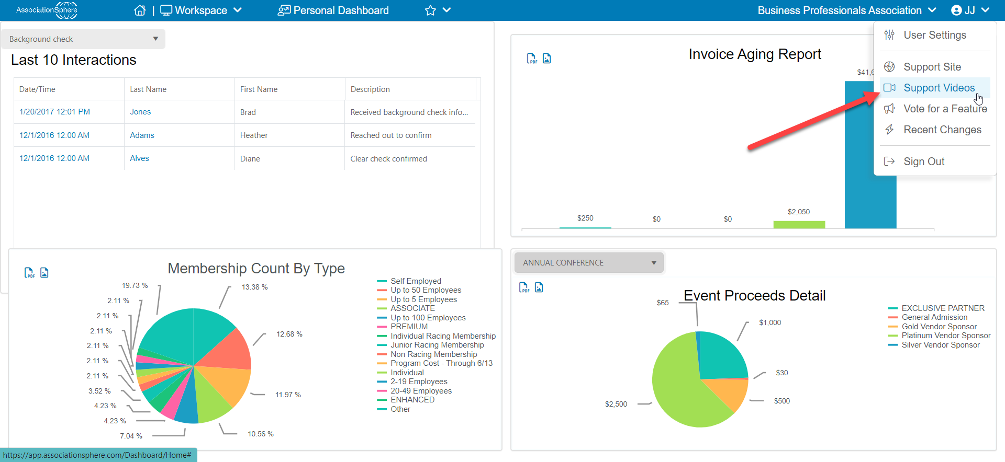
To access the different modules, click on the Workspace menu. Clicking on the module name navigates to a dashboard with statistics for the module. Click on the module name just to the right of the workspace menu to see all the data grids and activities to be accomplished in that module.
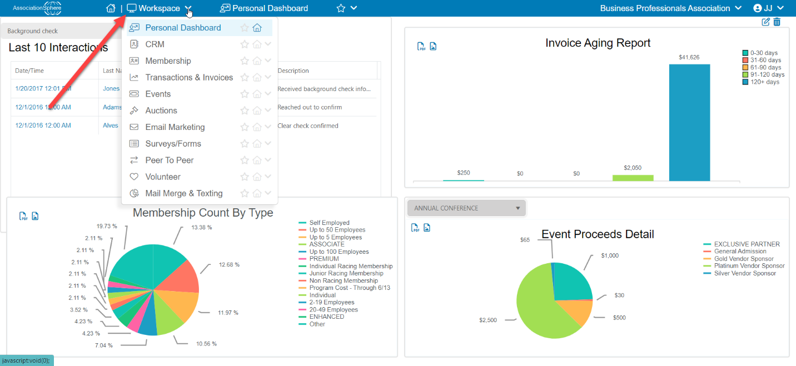

CRM (Constituent Relationship Management) Module
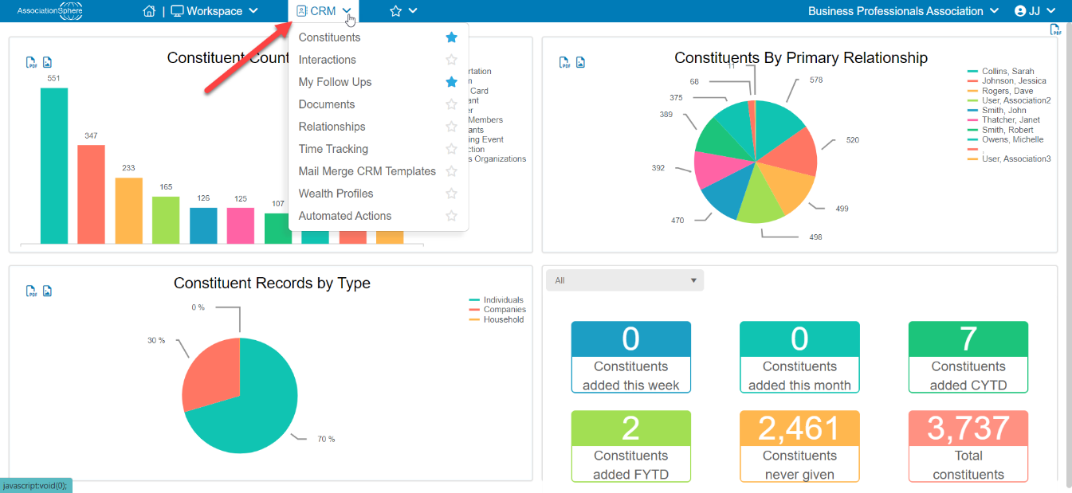
The CRM module is where the contact and summary information are contained about the constituents. A constituent is any individual or company that your organization interacts or communicates with including members, donors, volunteers, staff, granting agencies, vendors, email list subscribers, and more. Within this module there are several grids including the main Constituents Grid and grids to see all the Interactions, Documents, Relationships, and Time Tracking for all the constituents in the database. The grids are organized like a spreadsheet to show each constituent on a row with columns of data about that constituent.
A default view must be created for some of the grids within the database. If a default view is required, a pop-up message will appear to create the default view. Click on OK to build the default view.
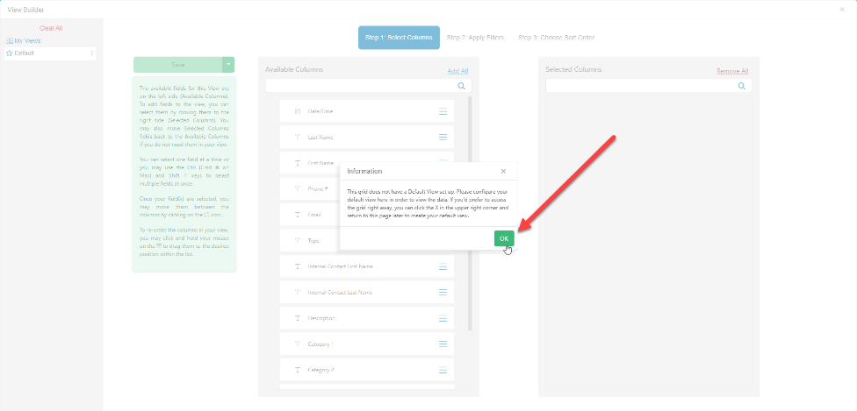
To begin, all the columns can be included by clicking on Add All on the left available column list.
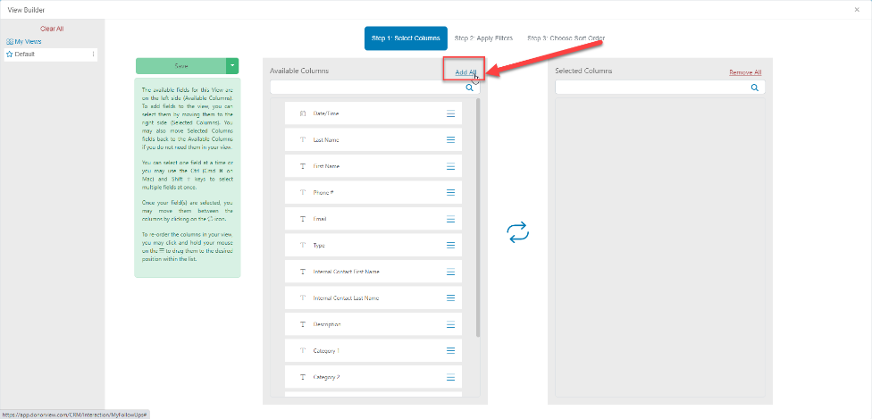

With all the columns added to the view, click on the small “x” in the top right corner of the window to close the view builder.
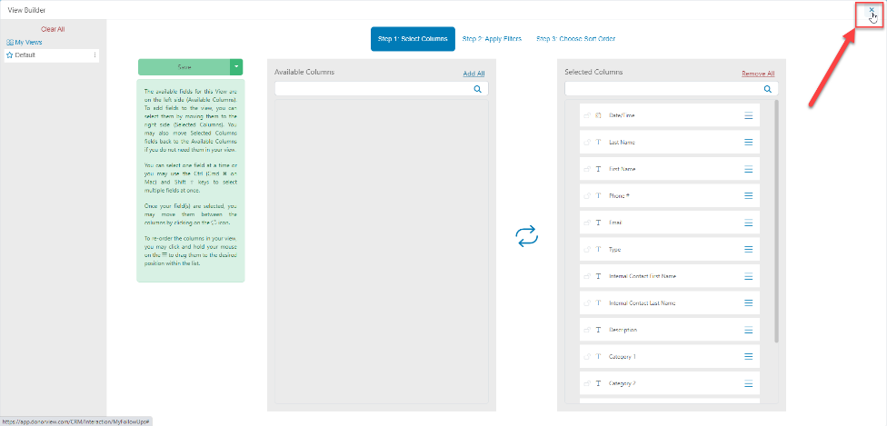

Then click the green “Save” button to open the grid view.
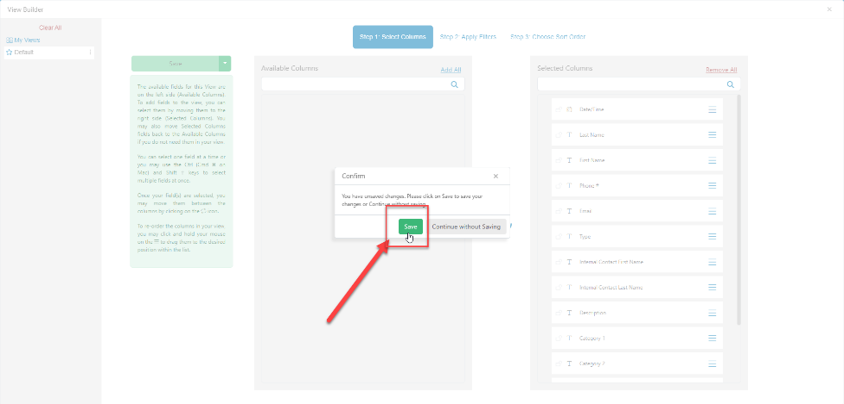

Many of the grids also contain a side bar to reveal the views and queries. If the gray sidebar is not viewable when the grid is opened, click on the small left facing arrowhead in the middle of the grid to reveal the side bar. The bottom of the side bar has a toggle to keep the sidebar minimized if to see the grid without the sidebar showing.
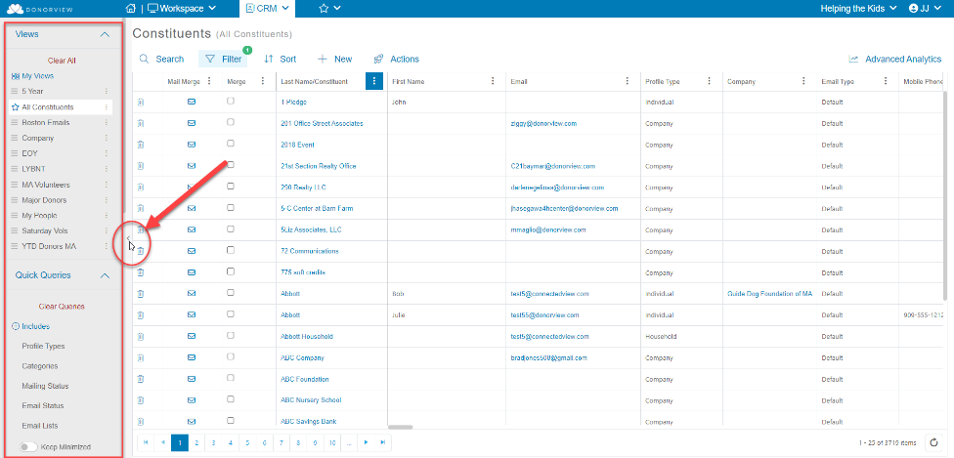

Constituent Grid
The constituent grid shows a spreadsheet-style list of all of the constituents in the database along with contact information including their address, email address, phone number, and summary information like their cumulative giving history, last gift date, and average gift amount. Reports can be quickly created using views and can be saved as a custom view, shared with other users, and even exported to Excel using the Actions menu. Learn more about it in the video “AS Constituent Grid.” (password AS2021)
Clicking on the row of a particular constituent will allows the use of the View/Edit menu at the top of the grid to open their profile page or any of their subpages to see more details of things like their giving, pledges, interactions, documents, relationships, events, memberships, and volunteer time. New donations, event purchases, and memberships can also be added to the profile record. If the constituent row has data in the Last Name/Constituent column, clicking on the name will go directly to their record, or right click on the name and open in a new tab. See the following videos to learn more about the features in the constituent profile records:
- AS Company Constituent Profile - https://vimeo.com/732208718/7546bf87f1
- AS Individual's Constituent Profile - https://vimeo.com/732175666/f9cc47faca
- AS Constituent Membership Tab - https://vimeo.com/723081021/81e9f30eef
- AS Constituent Events Tab - https://vimeo.com/725762519/9792d5c35e
- AS Constituent Engagement Tab - https://vimeo.com/854693059/c3bb61cbba
- AS Constituent Survey Tab - https://vimeo.com/738710672/dcd9c09734
- AS Constituent Email Campaigns Tab - https://vimeo.com/727877004/165869f6ba
- AS Constituent Payment Options Tab - https://vimeo.com/851331427/ecdf707d3a
Interactions Grid and My Follow Ups
The interactions grid provides a record of all interactions recorded for all constituents. Interactions can record any type of contact with a constituent including meetings, phone calls, reports. The types of interactions and categories of interactions are all fully editable.
For any interaction created, a follow-up interaction can also be created. For example, a meeting occurred with a member, and they requested a specific report. The meeting can be recorded as well as a follow up activity to assign and remind a user to send the report. Learn more about the Interactions and My Follow Ups grid in the video AS Constituent Interactions & Follow Ups -https://vimeo.com/728952337/78a4136ffb
Documents Grid
Documents like acknowledgement letters, end of year tax statements, and renewal reminders can be saved in the constituent’s records. Documents provided by the constituent, like copies of driver’s licenses or resumes, can also be uploaded. The documents grid provides a list of all documents saved in all the constituent’s records. Watch more about the documents grid in the video AS Constituent Documents - https://vimeo.com/729717303/2a1b7c3523
Relationships Grid
Constituents can be linked in the database via relationships. Relationships can include family, work, social, and other types of connections which are fully editable. The relationship grid includes a listing of all relationships of all constituents. Learn more about this feature in the video “AS Constituent Relationships.” (password AS2021)
Time Tracking Grid
Time tracking is used to document volunteer time, service, or education activities. Time can be recorded manually in the constituent’s record or set up to be added automatically through an event page. The time tracking grid includes the information for all time for all constituents. To learn more about the time tracking grid, see the video AS Constituent Relationships - https://vimeo.com/730124232/6ab9d7b567
Mail Merge CRM Templates
Mail merge letters and emails can be created from the reports generated in the constituent grid. The letters are saved in the Mail Merge CRM Templates library. The letters are built similarly to Microsoft Word and utilize the fields available in the constituent grid for the data.
Automated Actions
Automated actions will send emails to constituents, create notifications and follow-ups, and assign constituents to categories based on triggers. For example, automatic emails can be sent for constituent’s birthdays, or to send a notification to the development director when a constituent reaches a giving threshold to be considered a major donor. To learn more about automated actions, see the video AS Automated Actions - https://vimeo.com/736216737/98c309bcd4
General Membership Module
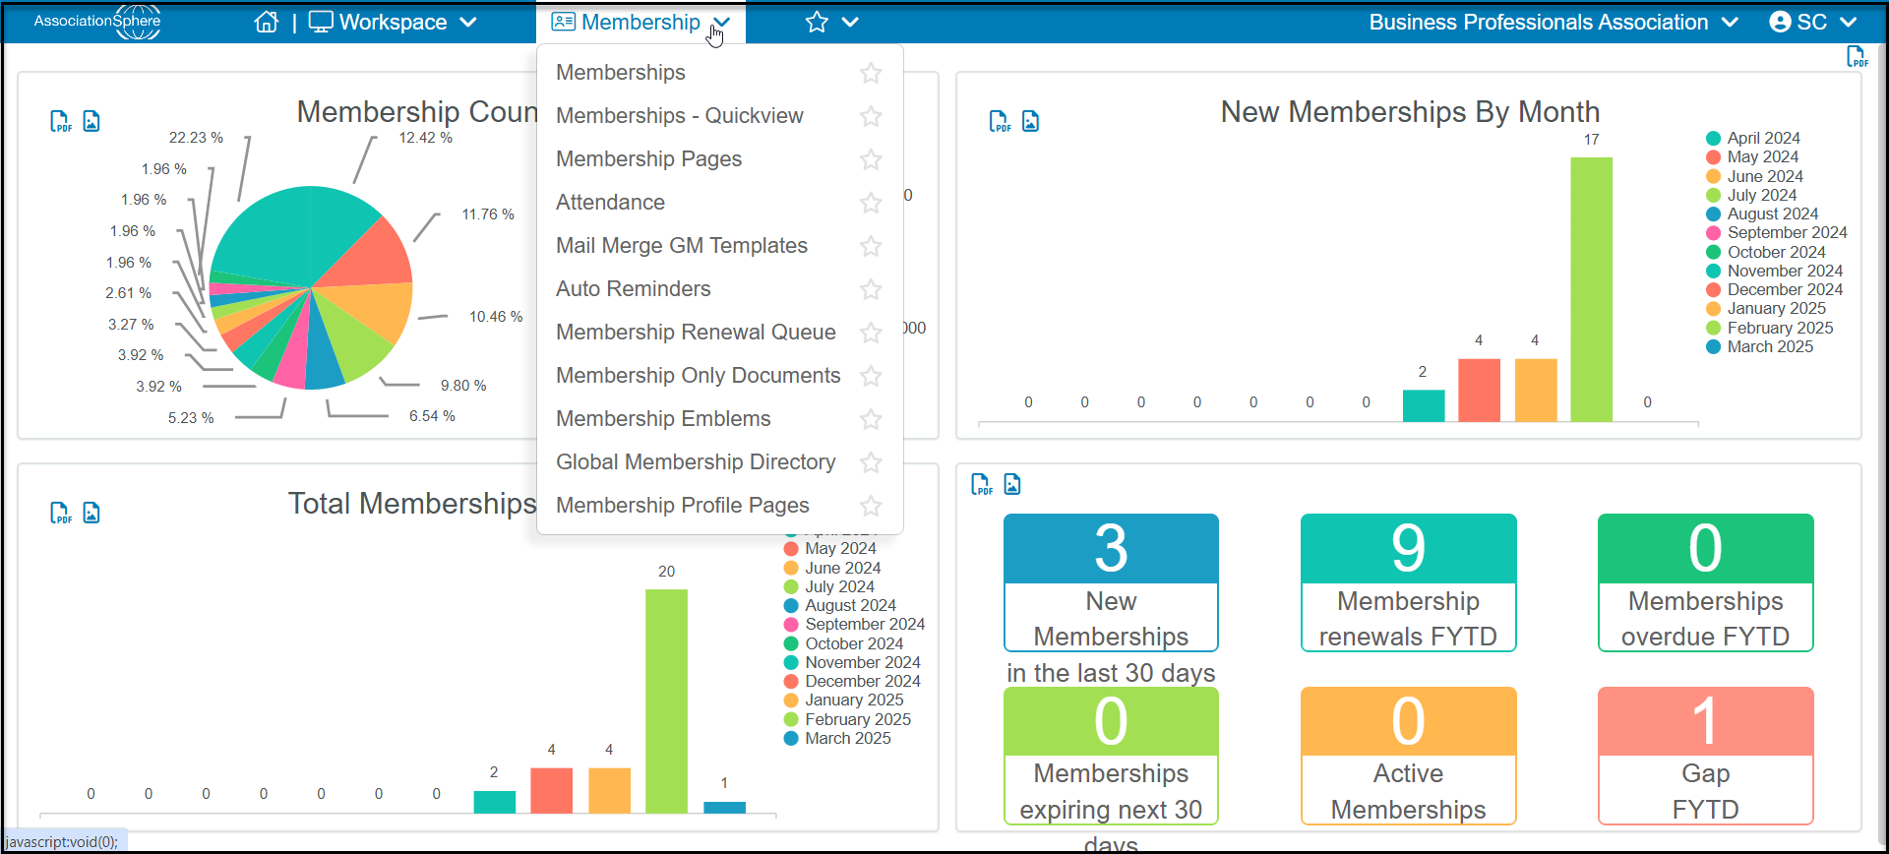

Membership
The main membership grid has two views, the summary and detail view. The summary view will show the most current owner for each membership with information about the transaction, amount due, the membership level, expiration date, and status. There is also a current membership expiration date and current status. The current membership expiration date will be the farthest expiration date of all transactions. The current status indicates if the membership is active, inactive, or pending (there is an amount due.) On the detail view, the purchaser and the additional members are shown. Learn more about this grid in the videos AS Membership Summary Grid - https://vimeo.com/723848218/3167b01066 and AS Membership Details Grid - https://vimeo.com/845703251/6c7c862917.
For memberships it is important to understand that there can only be one membership owner. There can be multiple members that are part of a membership level, like a small business memberships that includes 5 employees. All automatic renewal reminders will be sent to the membership owner. Note that if a company is the membership owner, an individual constituent record must also be created for the primary contact. The primary contact is required in order for the membership to be managed via the member portal. Also, if other employees for the company need to have portal access or receive member discounts for events, the membership will need to be created to include additional primary members. Those additional employees will also become constituents in the database in order to fully utilize the functions of the software.
Membership Pages
The membership pages are where the membership registration pages are built. The pages include settings, level set up, styling and automatic thank you emails. See the video AS Membership Online Form Setup - https://vimeo.com/856462329/67bd5752f1 to learn about building membership pages and managing memberships.
Attendance
An attendance grid can be generated for all active members. This is useful for membership events like networking events where a specific event page has not been created. To learn more about this feature, see the video AS Member Attendance - https://vimeo.com/720330915/6d7add0528.
Mail Merge GM Templates
Like the CRM, Fundraising, and Events modules, the membership module has its own library of mail merge letter templates. These letters get their merge data from the membership grid. The letters can be used to generate acknowledgements, renewal reminders, and other communications just for members. To see more about this topic, see the video AS Member Mail Merge Letters - https://vimeo.com/720739844/ff1868f2cd

Auto Reminders
Auto reminders are used for membership renewals and are only sent to the email of the membership owner. Like invoice auto reminders, these reminders are generated based on expiration date and member level or the current membership expiration date. The reminders use the email templates which can be customized. To learn more about this feature, see the video AS Membership Auto Reminders - https://vimeo.com/719972085/0e7472c9a4
Membership Renewal Queue
If you utilize the Batch Renewal feature on the Memberships grid's Actions menu, you can find the list and status of all your membership batch renewals.
Membership Only Documents
When the portal is activated, members can access a library of documents and links just for members. These documents can be for all members or linked to specific membership levels. See the AS Member Only Documents - https://vimeo.com/718018124/03cdc653e6 video to learn more.
Membership Emblems
The membership emblems allows you to create emblems to display on your membership directory for specific membership levels. You can learn more in this article: https://support.associationsphere.com/en/support/solutions/articles/67000731538-membership-emblems
Global Membership Directory
Each membership page creates a directory for the page. However, if you have multiple membership pages, you can create a widget for your website that combines all your membership pages into a global directory. You can learn more in this article: https://support.associationsphere.com/en/support/solutions/articles/67000731537-global-membership-directory
Membership Profile Pages
The membership profile pages can be used to show more details about your members. They can also be edited by the members themselves. To learn more about these features see these videos: Member Profile Widgets - https://vimeo.com/1070353279/7c56ffbbb0 and Member Profile Pages – https://vimeo.com/1070382992/772f3822be.

Transactions and Invoices Module
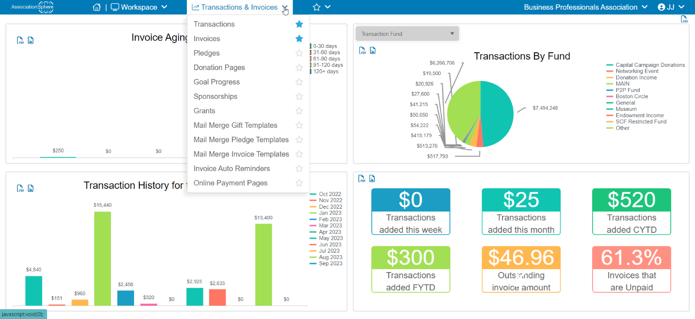
Transactions
The transactions grid contains information about each transaction, whether that is a membership, invoice payment, donation, pledge, pledge payment, event, or auction items purchase. Information is auto populated from the entries provided in the different donation, event, membership, peer-to-peer, and auction pages, as well as any contributions or pledges entered manually.
All transactions are identified by the type, for example general, in-kind, invoice payment, membership, or event. The grid also contains four columns of data, the For, Fund, Event and Appeal fields, which identify the revenue sources for creating specific views, queries, and reports. These four lists are editable for the organization’s needs. Many organizations will use the “For” field to identify the program, project, or campaign the money is earmarked for, such as the membership services or education program. The “Fund” field is often used to identify the bank account or financial area the money is deposited or designated for, such as the general fund or scholarship fund. The “Event” field can show several sources of revenue that are associated with an event such as a conference or networking event. And the “Appeal” field is often used to capture the responses to invitations, annual renewals, or the source of the contribution like the website or Facebook. For more information about this grid, see the video AS Transactions - https://vimeo.com/532301313/01c41472ba
Invoices
AssociationSphere has a feature to automatically generate invoices for “pay later” membership or event registrations. Invoices can also be manually generated for payments that are not linked to a membership or event purchase. All invoices get a unique URL created so that constituents can pay via credit card with their unique link. Learn about invoices in the video AS Invoices - https://vimeo.com/542720776/32a4854a72
Pledges
Within AssociationSphere pledges are a promise to make a donation in the future and are only used for donations. Once a pledge is created, a pledge payment can be received against the pledge. Pledges can be one-time, or they can be recurring payments made over a specific frequency, like monthly or quarterly payments. Pledges and pledge payments are recorded and shown on the Transactions Grid, but the pledges grid shows a detail view of the pledges with each payment due or a summary view which shows the total amount of the pledge, how much has already been paid and future payment information. For more information about the pledges grid, see the video AS Pledges Grid & Constituent Pledges Tab -https://vimeo.com/853378285/f3c4f933a2
Donation Pages
The donation pages grid is where online giving or payment forms are created. The pages can be customized and styled to suit the organization’s needs and there is no limit to the number of pages that can be created. Note these forms are generally used only for donations but can be used to accept payments not related to a membership or event. To learn more about creating a donation page, see the videos AS Donation Page Simple Designer - https://vimeo.com/773459948/6925f71d25 and AS Donation Page Advanced Designer - https://vimeo.com/989131347/8361d78611.
Goal Progress
The goal progress grid creates widgets for the organization’s website to show progress towards a goal, for example a thermometer showing how much has been raised towards the annual fund goal. Multiple pages, activities, and contributions can be combined into a single fundraising goal category, such as having a golf tournament, donations, and an auction all be counted towards a campaign goal. To see more about creating a goal progress widget, see the video AS Goal Progress - https://vimeo.com/773462639/f445523e28
Sponsorships
Sponsorships can be established for event levels, membership levels, and general support for the organization. The sponsorship page is where the names of the sponsorships are set up including what tasks (or deliverables) are required, and establishes the follow-ups required for the tasks. To learn more about the sponsorships feature, see the video AS Sponsorships - https://vimeo.com/850985562/8f6d8d17e8
Grants
If the organization applies for and manages grants, use the grants feature to enter the information. Grants can be linked to a donation entry when the grant is awarded. To see more about grants in AssociationSphere, see the video AS Grants - https://vimeo.com/851028977/a67ee81afd.
Mail Merge Gift Templates
The acknowledgement (or thank you) letters for general, in-kind, pledge payment and stock donations are created in the Mail Merge Gift Templates. The letters are built similarly to Microsoft Word and utilize the fields available in the gifts grid for the data. To learn more about this feature, see the video AS Transactions Mail Merge Letters - https://vimeo.com/852464582/e46358db12
Mail Merge Pledge Templates
Similar to the Transaction and Constituent mail merge letter templates, the pledge templates use the data in the Pledges grid to produce the letters. Learn more in the video AS Pledge Mail Merge Letters - https://vimeo.com/853397202/b775519c82
Mail Merge Invoice Templates
When using the Print/Email Mail Merge feature in the actions menu for invoices is used, a cover letter must be created for sending invoices. The cover letters are created in the same way as the transaction and pledge mail merge letters.
Invoice Auto Reminders
Auto reminders can be created for invoices and can be sent before or after the invoice due date. There are also auto reminders available for membership renewals and the process is covered in this video AS Membership Renewal and Invoice Reminders - https://vimeo.com/661176182/7aee63eb3c
Invoice Payment Pages
In order to generate invoices, an invoice payment page must be created. Payment pages can be customized, and different pages can be designed for events, memberships, and manual invoices. See the process for creating the pages in AS Invoices - https://vimeo.com/542720776/32a4854a72.
Events Module
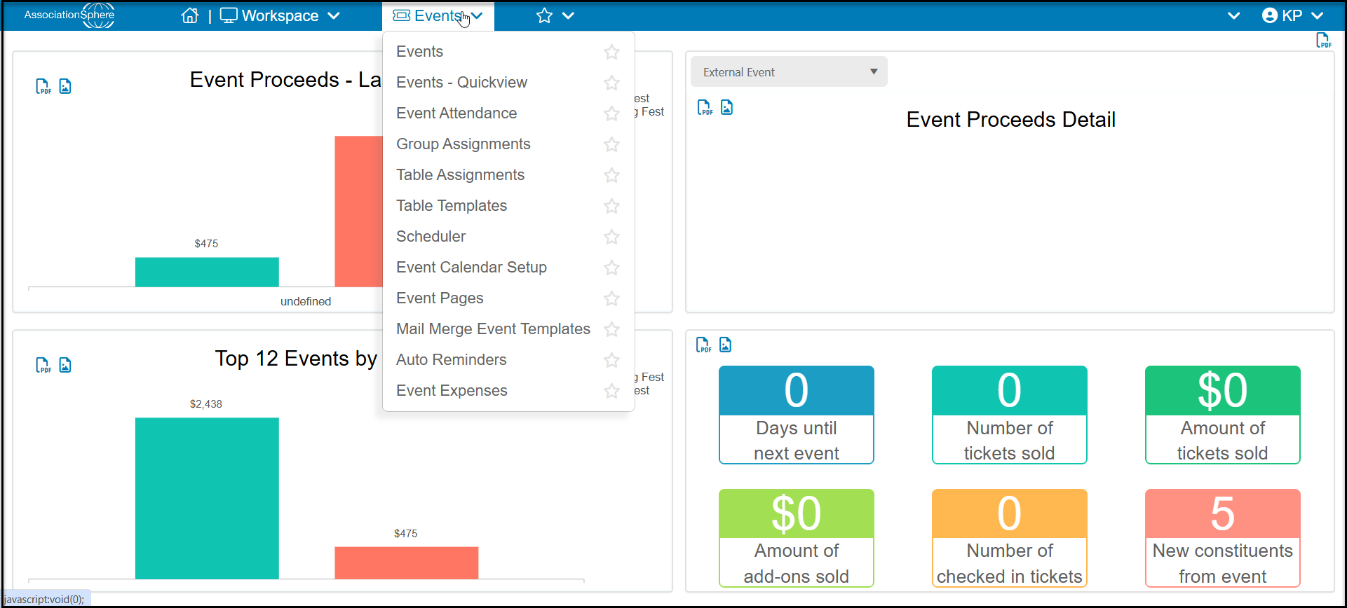

Events
The events grid provides the financial transaction information related to event purchases and registrations. To view the data, an event must first be selected from the queries column in the left side bar. There is a summary and a detail view. The detail view includes purchaser and attendee information. Learn more about this grid in the AS Event Summary Grid - https://vimeo.com/742261700/e87e1eb502 and Event Details Grid - https://vimeo.com/741951994/c5182d671b
Events – Quickview
The quickview shows the information about the event transactions but does not include the financial information for the amount paid and amount due. As with the events grid, the event must be selected from the queries side panel to populate the grid.
Event Attendance
The attendance grid provides the specific information about the actual attendees for the event. The grid shows the purchaser’s name in the Last Name/Constituent column. The other columns on the grid are about the attendee including their name, email address, and other information like the answers to attendee questions, bidder ID number, and table and event assignments. This grid is also used to update attendee information if the attendee’s name was not provided at the time of purchase or if the actual attendee has changed. Use the edit icon on the far left side of the grid to edit or update the attendee information. See more about this grid’s features in the AS Event Attendance Grid - https://vimeo.com/729647615/1d14d311d3 video.
Event Group Assignments
Event attendees can be assigned to custom groups. This feature is great for team sports like golf or bowling tournaments. When event assignments are activated on an event page (on the attendee info tab), event attendees can be manually assigned to a specific group in the event assignments page. See more about this feature in the AS Event Group Assignments - https://vimeo.com/735872886/65d2f39d24 video.
Table Assignments
The table assignments feature builds a map of the table and seating arrangements for an event. Attendee names can be dragged and dropped into their seats. The information can be exported as an Excel spreadsheet. Table assignments must be activated in the events page on the attendee info tab. To learn more about this feature, see the video AS Event Table Assignments - https://vimeo.com/732524596/42efcc8db1.
Table Templates
If the same venue or seating arrangements are used multiple times, a table template can be created and used to set up table assignments. This is covered in the same video as above.

Event Pages
Event pages are where the event specifics, ticket levels, and registration pages are created. Customize the page with event settings, level setup, collecting attendee info, styling the page, tickets, automatic thank you messages, and text-2-purchase features. Th event page can also link to volunteer activities, auctions, and peer to peer campaigns. To learn more about building the event page see the video AS Single Day Event Setup - https://vimeo.com/738347604/3be8b5b194
Mail Merge Event Templates
Like the CRM and Fundraising modules, the Events module also has a library of mail merge letter templates which derive their data from the events grid. Letters for things like event acknowledgments and sponsorship packages can be created here. To learn more about these templates see the video AS Event Mail Merge Letters - https://vimeo.com/730425038/b936f6b360
Scheduler
The Scheduler allows for a visual representation of Events Levels and their registrants on a calendar. Allowing users to better track registration across multiple events and levels on the days they are scheduled.
Event Calendar Setup
The Event Calendar is a link or widget that can be added to your website, email campaign or social media. The calendar can display both connected Events, which are setup as online forms through Event Pages or unconnected Events which are manually created directly on the calendar for display only. See the video AS Events Calendar - https://vimeo.com/743040429/e8e93a895a
Event Pages
Event pages are where the event specifics, ticket levels, and registration pages are created. Customize the page with event settings, level setup, collecting attendee info, styling the page, tickets, automatic thank you messages, and text-2-purchase features. Th event page can also link to volunteer activities, auctions, and peer to peer campaigns. To learn more about building the event page see the videos AS Single Day Event Setup - https://vimeo.com/738347604/3be8b5b194 Event Page Thank You Message - https://vimeo.com/752972784/322bafe71a, and AS Event & Attendee Questions - https://vimeo.com/732524596/42efcc8db1.
Mail Merge Event Templates
Like the CRM and Fundraising modules, the Events module also has a library of mail merge letter templates which derive their data from the events grid. Letters for things like event acknowledgments and sponsorship packages can be created here. To learn more about these templates see the video AS Event Mail Merge Letters - https://vimeo.com/730425038/b936f6b360.
Auto Reminders
Auto reminders can be set up for an event that are triggered by the purchase date, date of the event or on a specific date. The auto reminders use an email template which can be styled with photos, logos, links, and videos. To learn more about this feature, see the video AS Event Auto Reminders - https://vimeo.com/724864435/b0f7a89c1f.
Event Expenses
The event expenses feature is where expenses associated with an event can be recorded. Expenses can be linked to an event, categorized, include a description, vendor name, date, and amount. The grid can be filtered, and a total expense amount is shown under the amount column. To learn more about this feature, see the video AS Event Expenses - https://vimeo.com/728861447/83e9f150b9.
Auctions Module
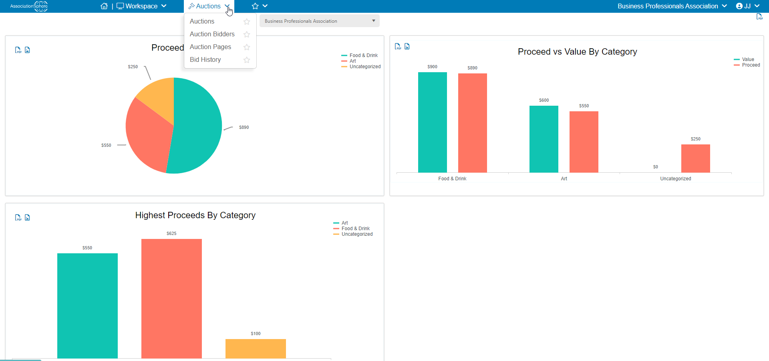
Auctions
The auctions grid is where silent, live, on-line, and hybrid auctions are managed. The grid shows all the auction and add-on items. The item descriptions, bidder sheets, and item certificates can be printed from this grid. The grid also has features for assigning bids, removing bids, viewing the winning bids for on-line auctions, and assigning add-on items for auction participants. The auctions grid is also where the guests are checked out and payments are processed. To learn more about the auction process, see the video AS Silent & Online Auctions - https://vimeo.com/527522336/867962e328
Auction Bidders
The auction bidders grid will show all the constituents who have either been assigned a bidder ID as an attendee to an auction event or those constituents who have registered for an auction that is not linked to an event. The actions menu includes features to communicate with bidders via email or text.
Auction Pages
The auction pages grid is where the list of all auctions are shown, and new pages can be created. The pages define if the auction is going to be a traditional silent/live auction or if participants will be able to bid online or via text. Online and text bidding require text messaging and the activation of the portal. Many types of auction items can be added or imported from in-kind donation records. Other types of items include donation options, buy-it-now items, and add-on items like raffle tickets and paddle raises.
Bid History
The bid history grid will show the current winners for all auction items. The history of all the bids can be viewed and all the items can be checked out at once if the auction is an exclusively online/text-2-bid auction.
Email Marketing Module
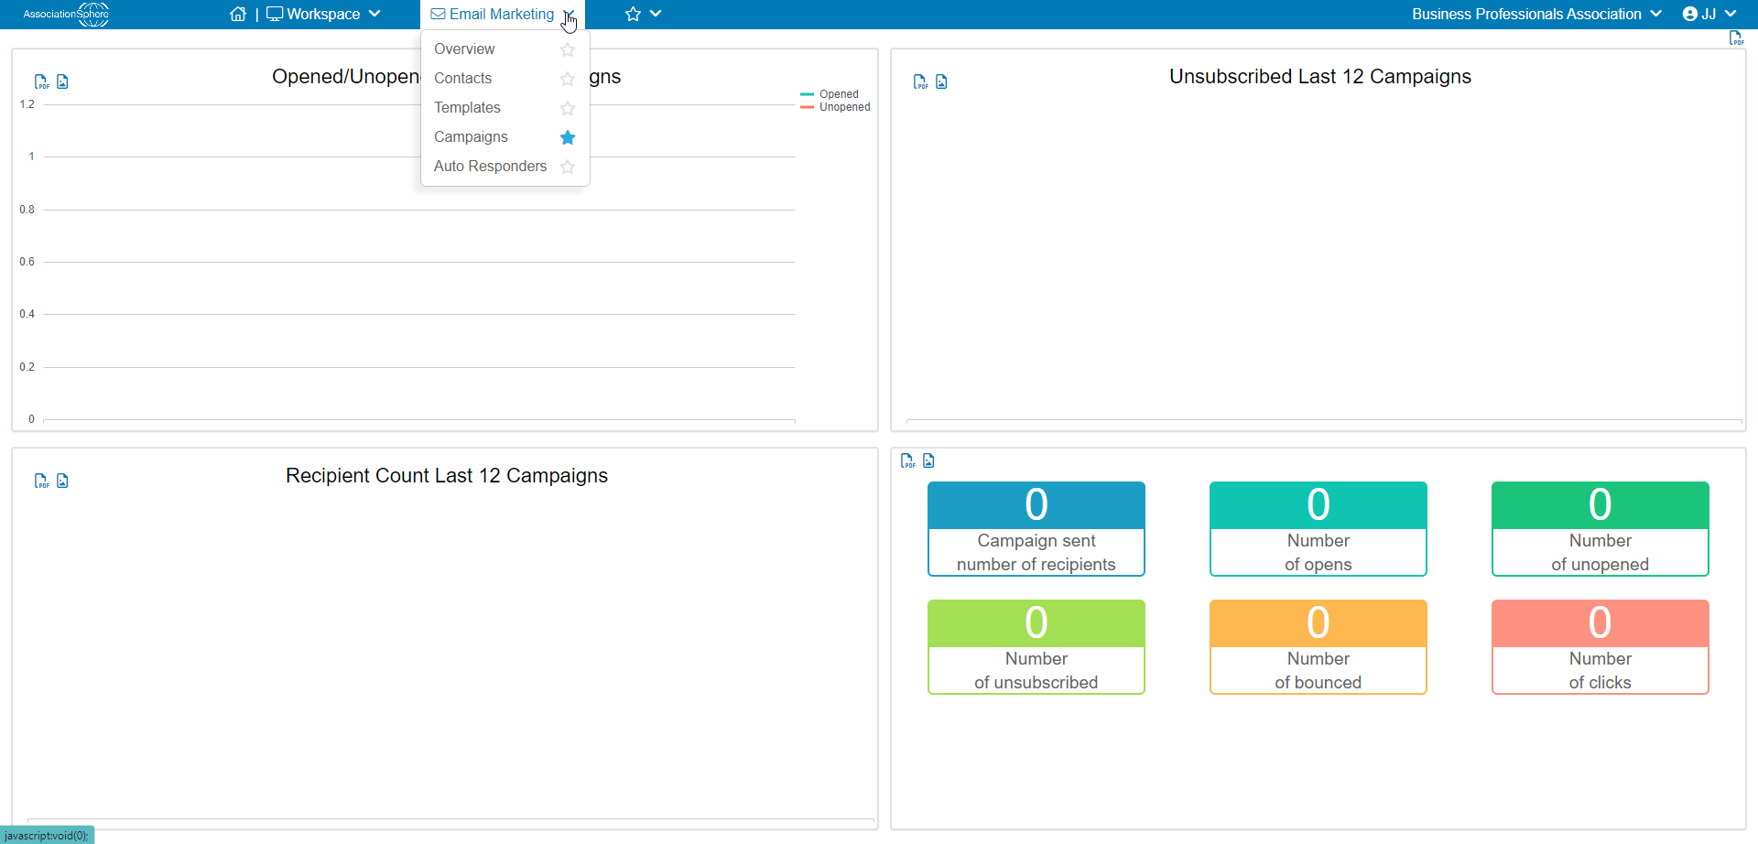
The email marketing module can replace other platforms like Contant Contact or Mail Chimp. To see the whole process, see the video AS Overview - Email Marketing - https://vimeo.com/532391003/77e133199d.
Overview
The overview feature shows the results of the email marketing campaigns. The dashboard shows the open, unopen, bounce, and unsubscribe statistics in the email delivery tab. The performance of any links and their monetization, as well as comparing the performance of the last 12 campaigns in the last 12 months is also available. See more in the video AS Email Marketing Overview Pages - https://vimeo.com/725754141/f7718b82e2.
Contacts
The contacts feature is where all the email lists and the constituents on those lists are managed. New constituents can be uploaded from Excel files or manually entered. Email list sign up links or widgets can also be generated here. Learn more in the video AS Email Marketing Contacts - https://vimeo.com/725408987/e81e980add.
Templates
The templates feature is used to create the emails for campaigns, auto reminders, and thank you emails for the various fundraising, event, and membership pages. The templates can be customized by adding images, text, and links to videos and pdf files. To learn about editing the email marketing templates and emails, see the video AS Email Editor - https://vimeo.com/532391003/77e133199d.
Campaigns
The campaign is where the contacts list comes together with the template. A campaign can be sent immediately or scheduled for a specific time and day. The video AS Email Marketing Campaign - https://vimeo.com/728195047/48df26d926 will demonstrate all the features.
Auto Responders
Auto responders schedule a template to be sent to new email list subscribers. The email list categories are identified to receive the message and the template can be customized for a general welcome or specific categories. See the details in the video AS Email Auto Responder - https://vimeo.com/727850988/34dfe23d38.
Surveys/Forms Module
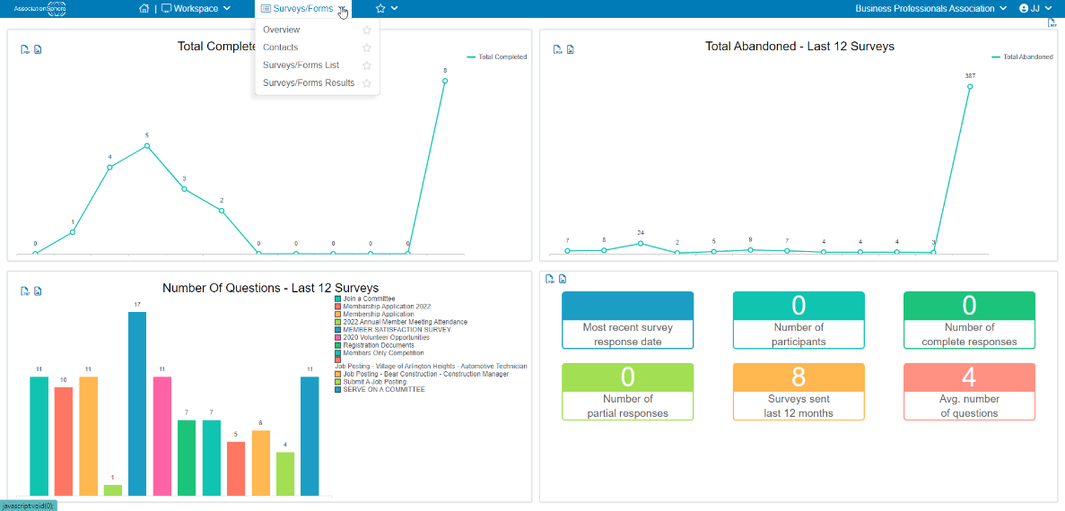
Overview
For surveys or forms that are sent via email, this feature works just like the email marketing overview feature to view the survey open rates and other statistics. See more about sending surveys and forms via email in the video AS Survey/Form Distribution Through Email -https://vimeo.com/740058743/c3a7952456.
Contacts
The contacts list is the same email contacts list found in the email marketing module. All the same functionality is available and lists and constituents can be added and edited here as well.
Survey/Forms List
The Survey/Forms list shows all the previously built surveys, polls, applications, and other forms that have been created and is where new forms can be developed. The forms can be internal, shared via URL link, and emailed. There are a variety of question types, including questions that can auto populate fields in the constituent’s profile. The forms can be made with or without logic. Learn more about building your forms in the videos AS Single Page Survey/Forms Setup - https://vimeo.com/743130979/e49688112d, AS Internal Survey/Forms - https://vimeo.com/738688606/bbc74ef8fa, and AS Survey/Form Question Logic - https://vimeo.com/740017644/54dba7127a.
Survey/Forms Results
The statistics are shown in the summary view and the individual responses can be seen by clicking on the details radio button for a short form or long form view. There is also a feature to drill down into the results when multiple choice questions are used. You can see more about these features in the AS Survey/Form Review + Results - https://vimeo.com/740770548/e190746469 video.
Peer-to-Peer Module
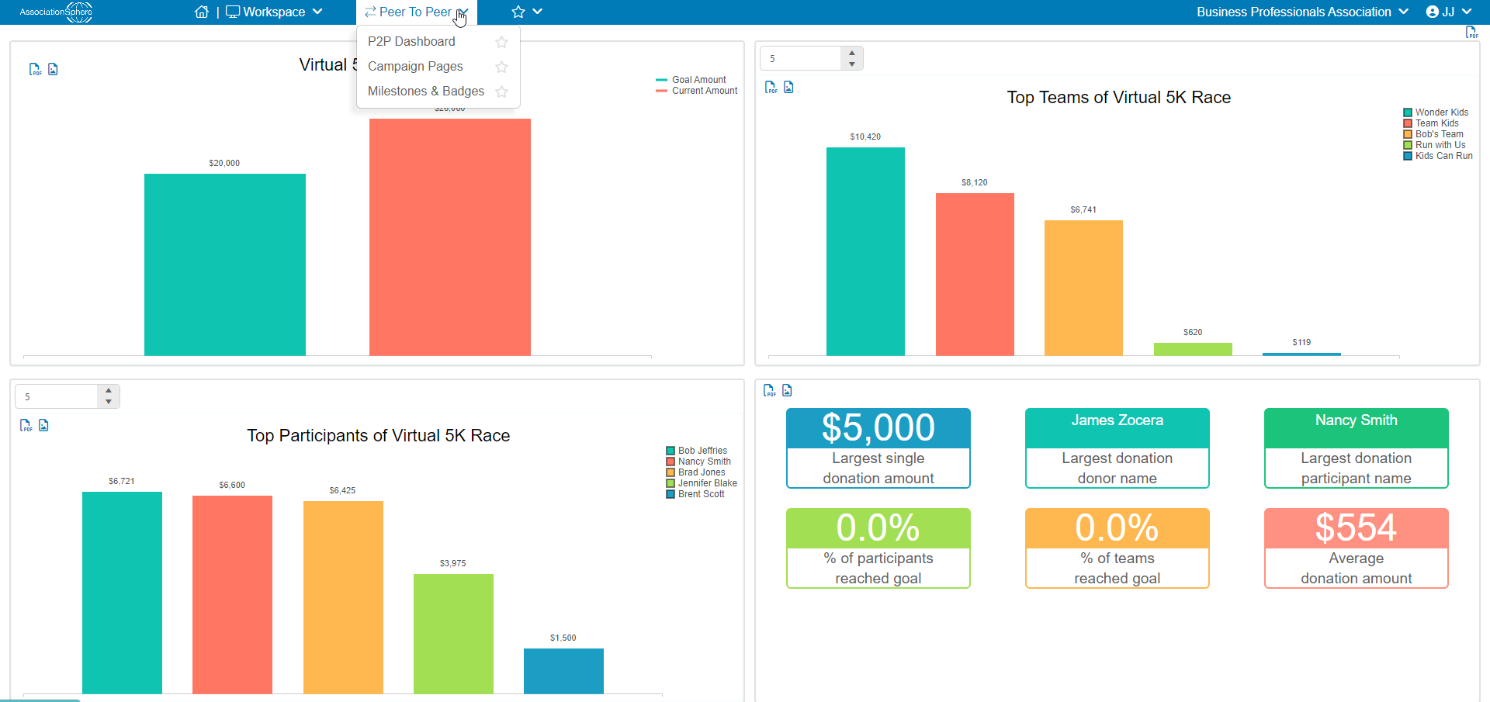

P2P Dashboard
The P2P campaign dashboard has two views, the summary and detail views. The summary view shows a list of all the participants and teams which have raised money, and it shows the total that team or participant had raised. The detail view shows all the individual donations and which participant or team that was designated for the gift. Like all grids, the actions menu includes exporting views to Excel, emailing and texting participants, and performing batch updates. To learn more about peer to peer campaigns, see the video AS P2P Fundraising - https://vimeo.com/525764190/585df3a286
Campaign Pages
The P2P campaigns are built in the campaign pages. Campaigns can be stand-alone or tied to an event. P2P campaigns require activation of the donor portal. The portal is where participants build their personal and team pages. To learn more about building the campaign pages, see the video referenced above.
Milestones & Badges
Milestones and badges are tools to keep the participants and teams engaged in the campaign. Milestones can be established for financial goals and simple activities like sending emails or creating a team. Once the milestone is achieved, the participant or team will receive a badge on their fundraising page and a thank you email generated automatically.
Volunteer Module
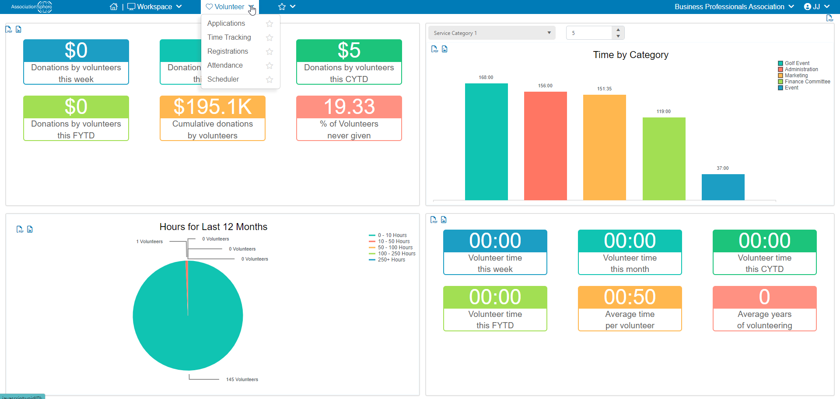
Applications
When a survey/form is identified as a volunteer application, those applications are linked to the volunteer module. The applications page shows the summary and detailed information of the applications. To learn more about the volunteer module, see the video AS Volunteer Management - https://vimeo.com/530891927/4940d62e1c

Time Tracking
The time tracking grid will show time for any constituent identified as a “Volunteer” in the constituent category. Time can be added manually via the +New feature on the grid, by adding time in a constituent’s record, and added automatically when the volunteer is checked in to a volunteer event.
Registrations
For events that are identified as volunteer events in the settings tab, the registrations grid will show all the volunteers signed up for volunteer events. The registrations grid works like the events grid and has a summary and detail view. The volunteer event must be selected first to populate the grid. You can learn more about creating volunteer event pages in this video AS Volunteer Event Setup - https://vimeo.com/759083422/d1640e4ad1
Attendance
The volunteer attendance grid works like the event attendance grid and will show all the actual attendees who are registered for the volunteer activities. This is the grid where volunteers are checked in to their volunteer shift and the time is automatically applied to their time tracking.
Scheduler
The scheduler provides a visual representation of volunteer shifts set up in a volunteer event. Volunteers can be registered for specific activities and shifts from the scheduler.
Mail Merge and Texting Module
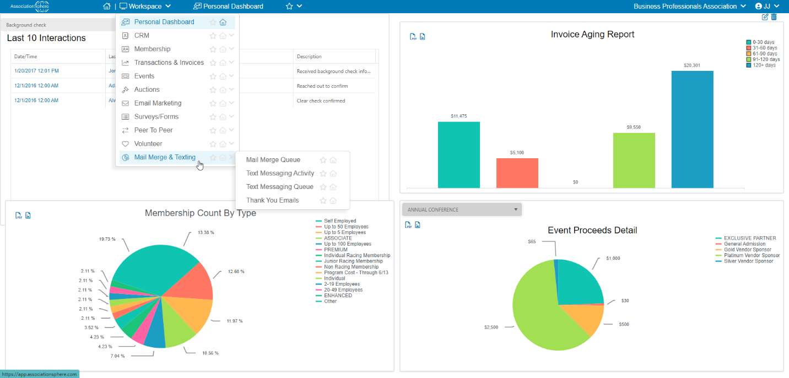

Mail Merge Queue
Sometimes when large mail merges are prepared, the system will run the merge in the background to allow continued use of the database. An email will be sent to the user when the mail merge is completed, and the merge letters can be retrieved from a link on the mail merge que grid.
Text Messaging Activity
If text messaging is activated, this grid will show the virtual phone number that is used to send text messages from the software. The grid will show all the incoming and outgoing messages and provide a count of the number of messages allowed for the day. This number only counts outgoing messages initiated via an Action menu to send a text message to constituents, members, or event attendees. The automatic replies, auction bids, and incoming messages do not count against the daily total limit. Text2URL codes can be created in the actions menu and the error message can also be customized here. To see more about text messaging, see the video AS Text-2-Give & Text Messaging - https://vimeo.com/528917375/aa8cd486dc
Text Messaging Queue
Scheduled text messages can be seen in the text messaging queue. The list will show scheduled messages and a summary of executed messages including the recipients and message.
Thank You Emails
All automatically sent emails from the various fundraising, event, and membership pages are saved in the thank you emails grid. The emails can be viewed and resent if desired.
Organization Settings
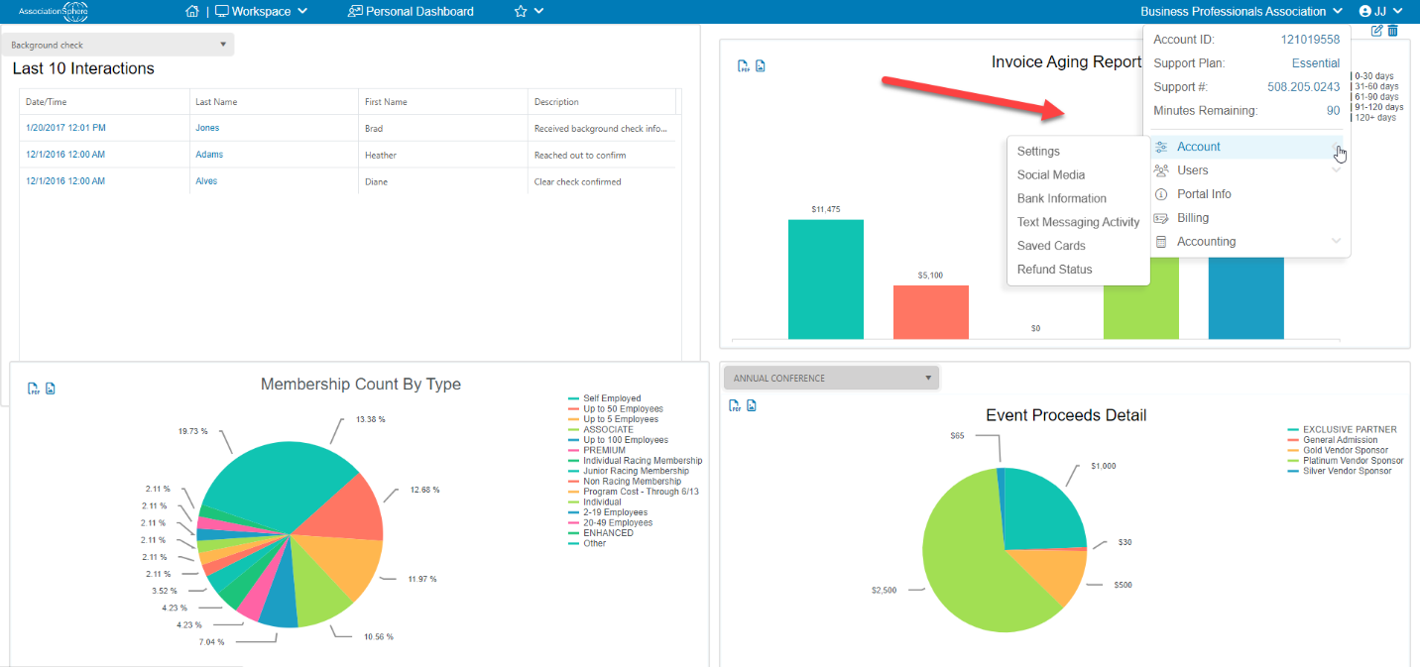
The organization settings are found in a menu under the organization’s name in the top right corner of the screen. The Account ID, Support Plan, and support phone number can be found here.
Account
In the account menu, the account settings link is where the organization’s info and logos are updated, the status for payment methods is shown, and different options can be activated. The social media accounts can be entered for auto population in email marketing templates. If the organization wishes to use multiple bank accounts, the bank information can be customized for each fundraising, event, and membership page. There is a list of saved credit cards to keep track of expiration dates. And the refund status will show the progress for any refunds that have been initiated. Watch more about account settings in the video AS Account Settings - https://vimeo.com/854796642/bd3ebb0f73.
Users
The AssociationSphere users menu is where new users are added, and security settings can be modified. The mobile users menu is only used for youth memberships. The portal users grid provides a list of all constituents who have created a portal account. Learn more about users in the video AS Account User Management - https://vimeo.com/855091980/a8b70f4a22.
Portal Info
Each organization will have a unique URL for constituents to create a portal account. Depending on the setup here, the constituents can have access to their donation history, pledges, events, memberships, documents, as well as the ability to update their own personal information, manage their subscriptions, passwords, and credit card payment methods. The video AS Member Portal - https://vimeo.com/536906471/86b036e683 demonstrates the features of the portal.
Billing
The billing information includes tabs to see the current credit card on file to pay AssociationSphere invoices, a grid for copies of those invoices, the statements to show constituent credit card charges and the associated bank deposits, which services are activated, and a grid showing minutes that have been recorded for support plans that include phone support. See more about billing in the video AS Account Billing - https://vimeo.com/855137192/5c638f6874.
Accounting
Under the accounting menu is where the QuickBooks chart of accounts, lists and general ledger mapping are found. This is also where transactions can be exported from AssociationSphere to a QuickBooks IIF file or connected directly to QuickBooks online.

User Settings
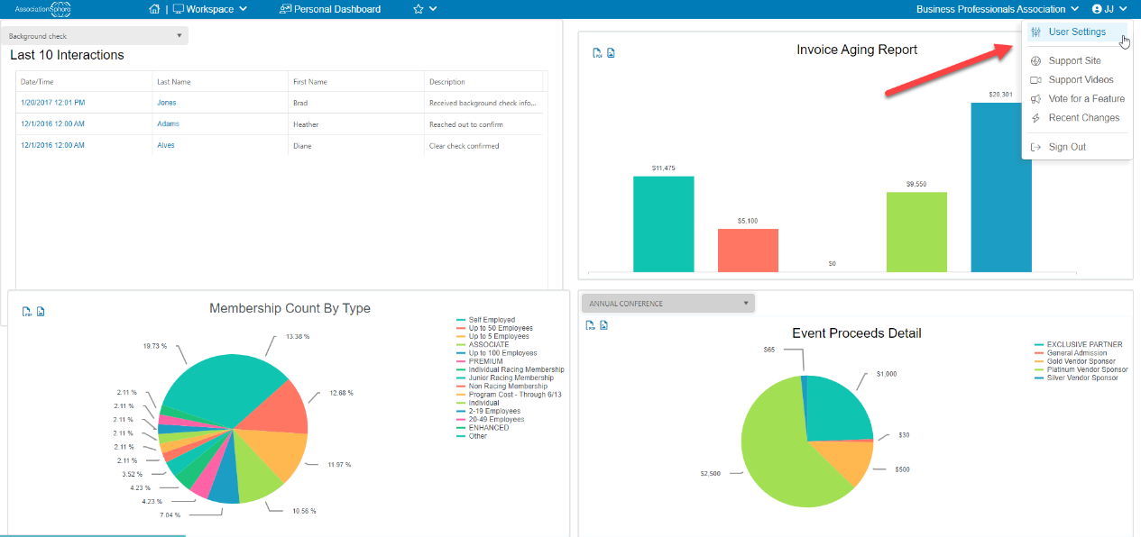
User Settings
The user settings can be customized for each user with the name, login ID, turning on follow-up email reminders, and allowing direct emails to be sent from the software. Learn more in the video AS User Settings - https://vimeo.com/854726189/e8c5d205f8
Support Site
The support site links to the knowledge base with articles covering all the modules and activities in AssociationSphere. New support tickets can also be generated from this link by clicking on “New support ticket.”
Support Videos
The support videos library link is here. The password hint is shown, AS2021, and click Launch Videos to view all the videos.
Vote for a Feature
Vote for a feature is where suggestions can be made to improve the software. The AssociationSphere development team routinely reviews this list for future software updates. New suggestions can be made, and users can vote for other suggestions, too.
Recent Changes
Updates to the software are made several times each year. Information about new updates are posted on the website with links to articles and videos covering the new changes.

AssociationSphere App
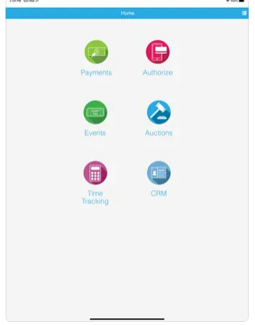
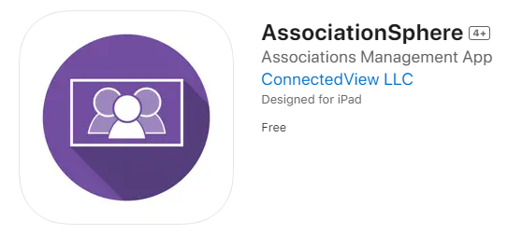
AssociationSphere has an app for in person events that syncs with Bluetooth credit card swipers. The app is currently only available on iTunes for Apple products like iPhones and iPads. The app has limited functionality however it can perform activities like checking guests into an event, authorizing credit cards, selling tickets, accepting donations, and processing auction purchases. To see more about the app, watch the video AS Mobile App - M2 Stripe Swiper - https://vimeo.com/1024071965/8602e0b115

